Waabanong Weekly Update
Delivered July 27, 2026
Week of July 20 to 24, 2026
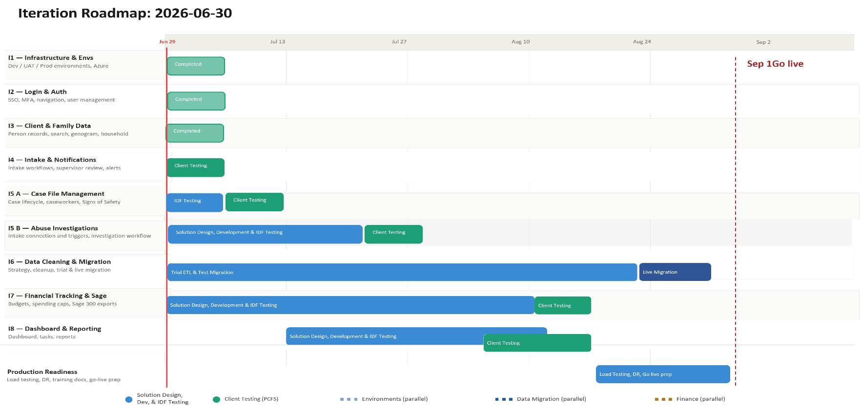

Iteration | Status | Current phase | Notes
I1 - System Infrastructure & Environments | Complete | Maintenance | Version bump alongside abuse-module feature flag rollout
I2 - Login & Authorization | Complete | Maintenance | No changes this week
I3 - Client, Member & Family Data | Complete | Maintenance | No changes this week
I4 - Intake Management & Automated Notifications | Complete | Maintenance | No changes this week
I5 A - Case File Management & Signs of Safety | In Progress | Bug Fix | Legal Status and Resource Home review task bugs fixed
I5 B – Abuse Investigations | In Progress | Development | Heavy referral-form and investigation-record development
I6 - Data Migration | In Progress | Design | Cutover plan under review; contingency-budget risk first flagged (no dev commits this week)
I7 - Financial Tracking & Exports for Sage | In Progress | Design | No activity this week
I8 - My Dashboard & Reporting | Not Started | — | No activity this week

Project Management & General
Weekly Progress
- Rob reviewed the data migration/cutover plan (Jul 21) and flagged that FAMCare's database structure is rougher than anticipated — the migration will likely require the project's contingency budget; kept the pre-go-live stress test in the plan at Ross's specific request
- Confirmed FamCare will remain accessible (not read-only) for a few months post-cutover so staff can look up historical records; this will be communicated internally rather than enforced in the app, since IDFusion has no access to modify FamCare
- Case management module UAT walkthrough scheduled via email — targeting Friday Jul 24 or the following Monday — to formally kick off case file UAT and bring two new CRD testers into the pool
- Ross confirmed (Jul 24) readiness to begin building the Waabanong production environment, with a kickoff meeting planned with Campfire Help Desk for the following week
- Abuse Module UAT confirmed not expected ready until the week of Aug 3, as internal testing on the module was just getting underway
I1 - System Infrastructure & Environments
Features
- Set up Development, Testing, and Production environments
Weekly Progress
- Version bump alongside this week's abuse-module feature flag work
I2 - Login & Authorization
Features
- Microsoft 365–based authentication
- User login
Weekly Progress
- No authentication changes this week.
I3 - Client, Member & Family Data
Features
- Centralized person records (children, adults, limited profiles)
  - Duplicate prevention
- Family and household structures
  - Multi-generation relationships
- Reciprocal relationship logic
- Global search across people and families
Weekly Progress
- No changes this week.
I4 - Intake Management & Automated Notifications
Features
- Structured intake workflows with mandatory fields
- Intake status tracking and lifecycle
- Supervisor review and approval processes
- Ability to resolve intake without opening a case
- Escalation from intake to case creation
- Printable intake records
- Automated notifications:
  - In-application alerts
  - Defined external channels (email/messaging)
Weekly Progress
- No changes this week.
I5 A - Case File Management & Signs of Safety
Features
- Case file creation and lifecycle management
- Assignment of caseworkers and supervisors
- Case reassignment with approval
- Signs of Safety–aligned workflows, including:
  - Placement
  - Structured assessments
  - Safety goals and planning
  - Ongoing review checkpoints
- Visibility into historical and related cases
- Case notes for visits, services, and interactions
- Communication tracking across intake and case contexts
  - Document management: Person, Intake & Case
Weekly Progress
- Fixed Legal Status Expiry Check autogenerated tasks not appearing
- Fixed 90-Day Resource Home review task not appearing
I5 B – Abuse Investigations
Features
- Triggers and integration with Intake module
- Investigation workflow
- Investigation document management

Weekly Progress
- Referral forms enhanced with required field validations, custom date-range filters, and improved pagination
- Investigation activity and referral form improvements for data integrity
- Abuse module authorization improvements, PDF snapshot handling, and address management in referral forms
- Offender role handling improved in investigation records and search queries for accuracy
- Feature flag added for the abuse module ahead of internal testing rollout
- General abuse module bug fixes
I6 - Data Cleaning and Migration
Features
- Develop a data migration strategy from FAMCare into Waabanong
- Support PCFS as they perform data cleanup
- Execute trial data migrations in a sandbox environment
- Perform live data migration
Weekly Progress
- Cutover plan (drafted the prior week) reviewed and revised based on IDFusion's own internal feedback
- FAMCare's database structure identified as rougher than expected, which will likely require use of the project's contingency budget for migration cleanup
I7 - Financial Tracking & Exports for Sage
Features (Potential scope may include)
- Intake-level emergency supports
- Case-level budgets
- Spending caps and approvals
- Export files to import into Sage 300
Weekly Progress
- No activity this week.
I8 - My Dashboard & Reporting
Features (Potential scope may include)
- My Dashboard (simple, quick reference to key items)
- Tasks & alerts
- Reporting (if required and not covered in other iterations)
Weekly Progress
- No activity this week.

